DAX & Data Visualization

Modeling:
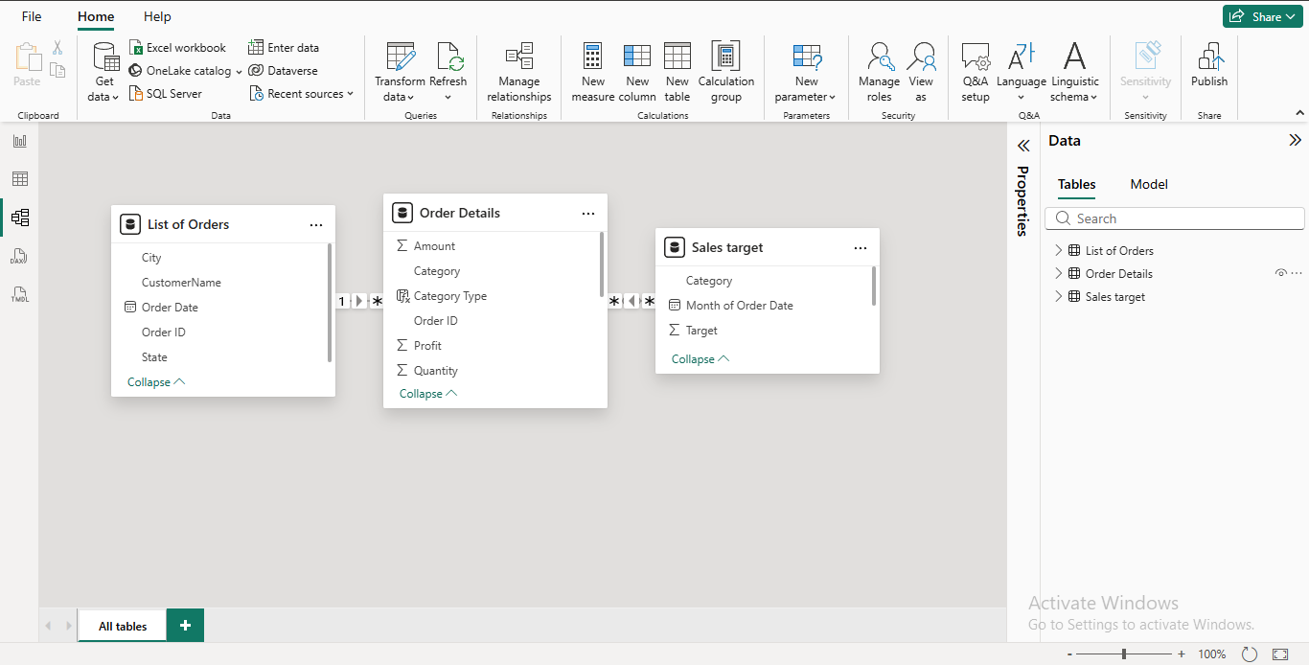

Calculated Columns:
- Category Type = 'Order Details'[Category] & " - " & 'Order Details'[Sub-Category]
- Revenue per Order = 'Order Details'[Amount] * 'Order Details'[Quantity]
- Sales Category = IF('Order Details'[Amount]>= AVERAGE('Order Details'[Amount]),"Above Average","Below Average")

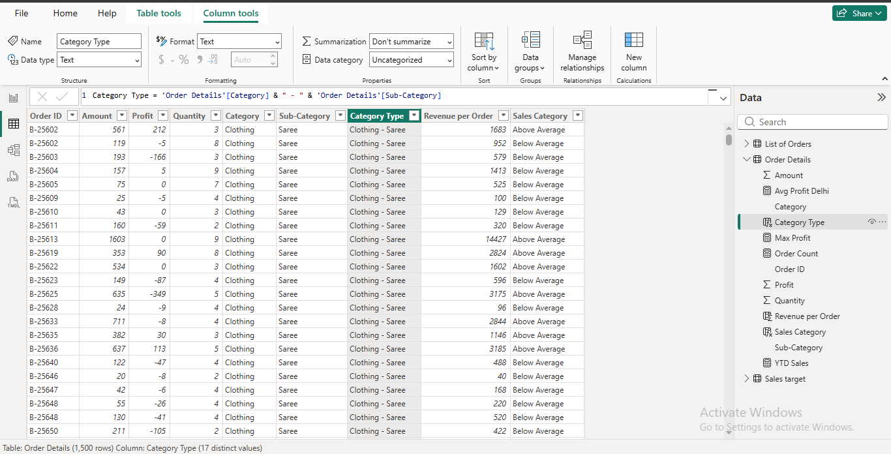

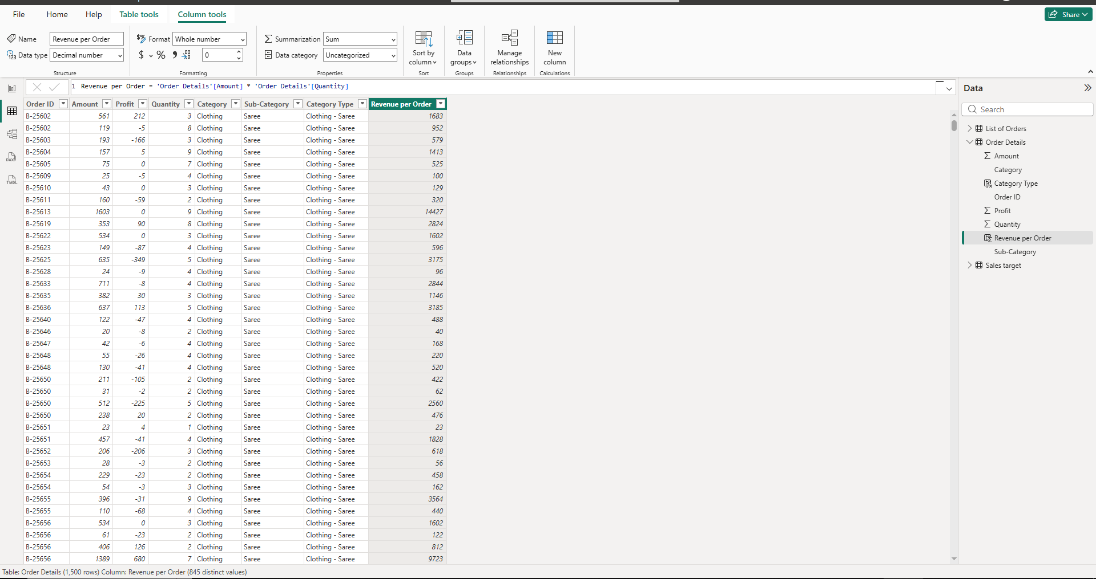
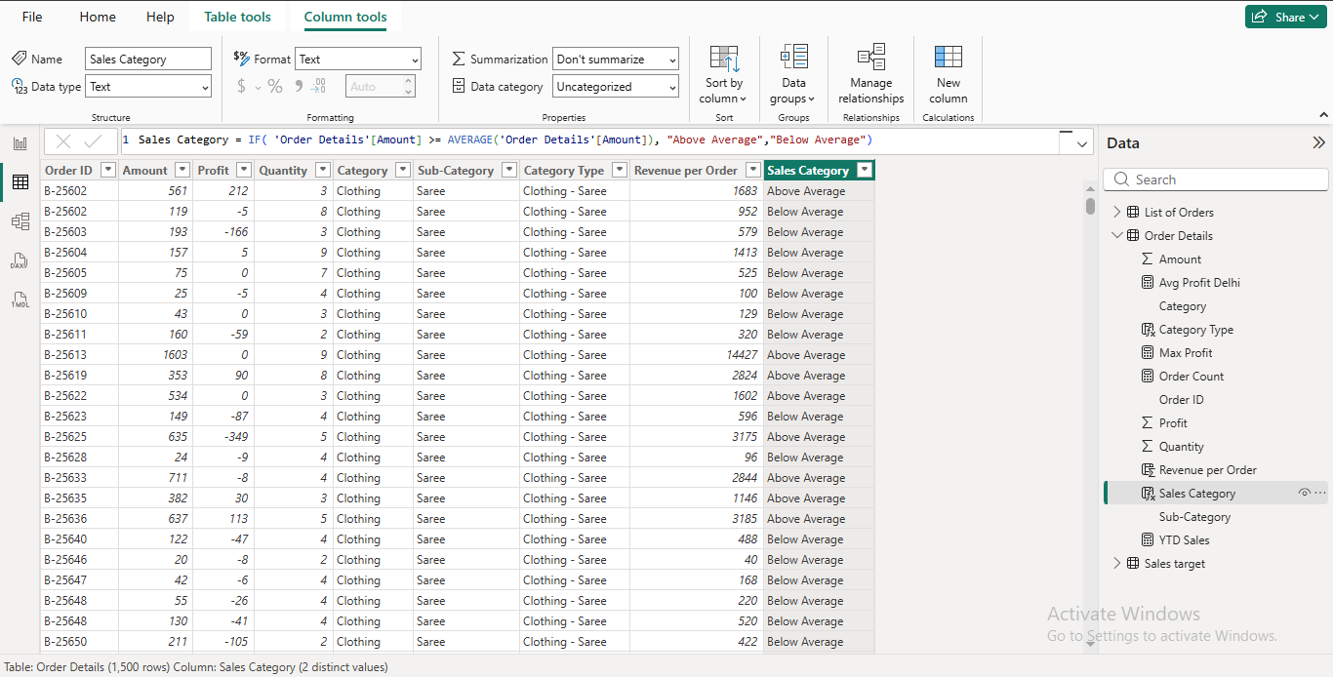

Calculated Measures:
- Order Count = Count ('Order Details'[Order ID])
- Avg Profit Delhi = Calculate (AVERAGE('Order Details'[Profit]),'List of Orders'[City] = "Delhi")
- YTD Sales = TotalYTD (SUM('Order Details'[Amount]),'List of Orders'[Order Date])

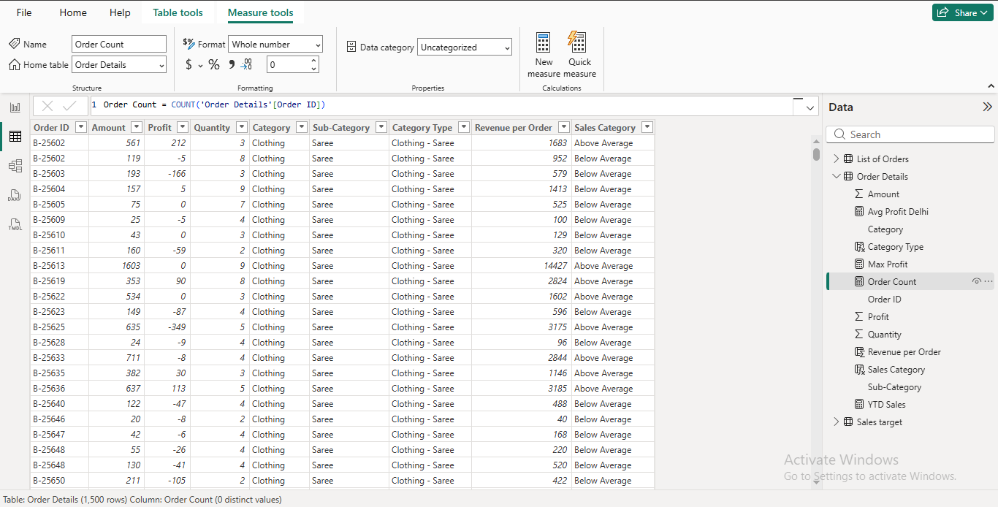

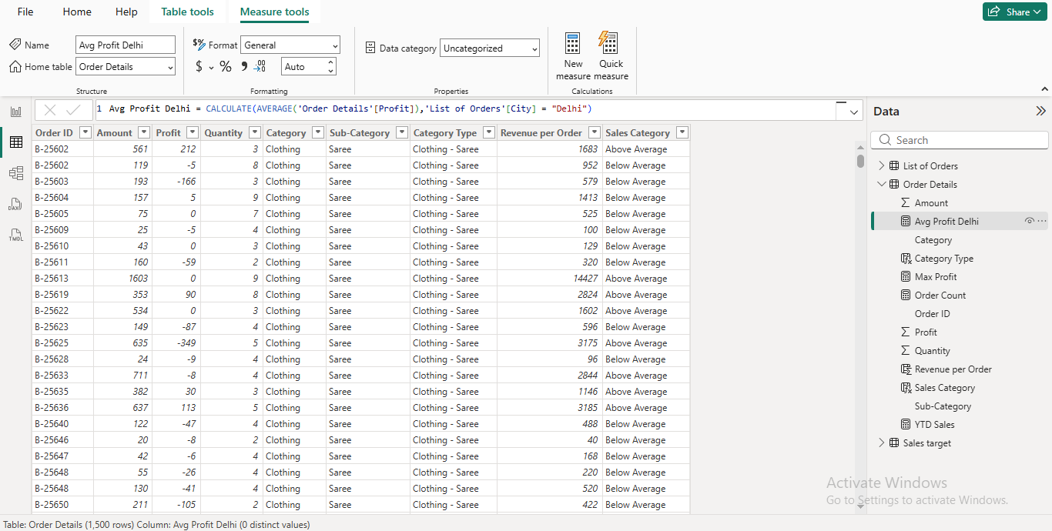
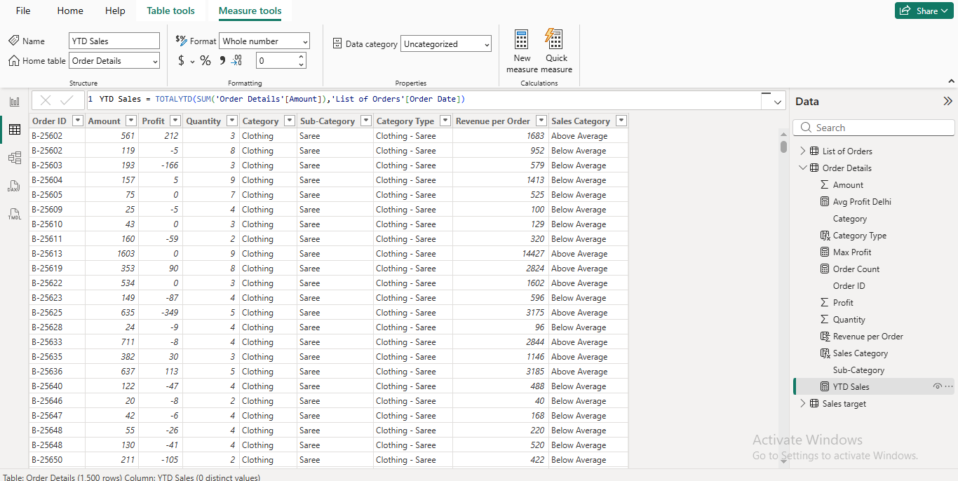
Data Visualization
Clustered column chart:
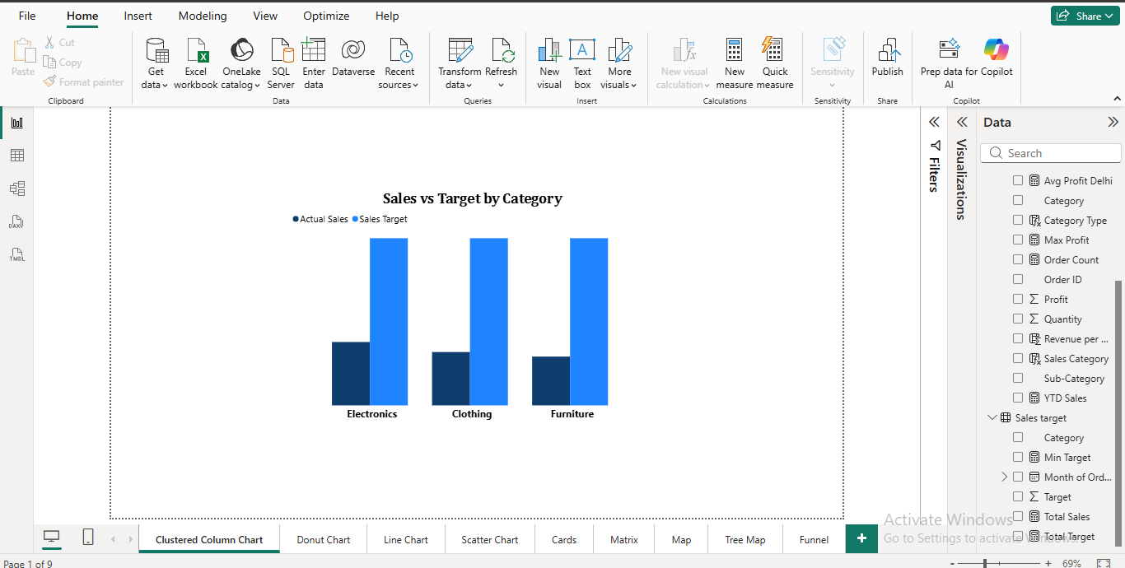
Max Profit Margin:
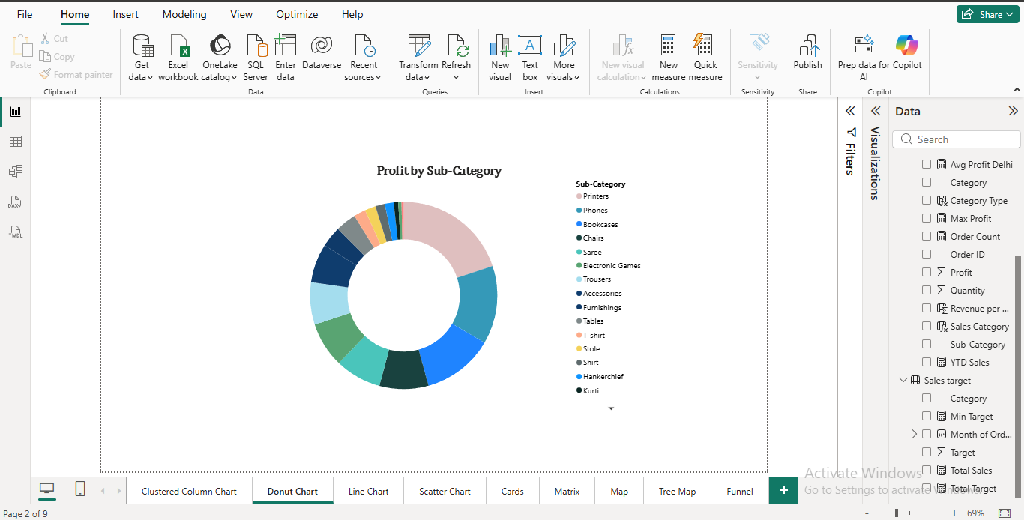

Monthly Sales Trend:
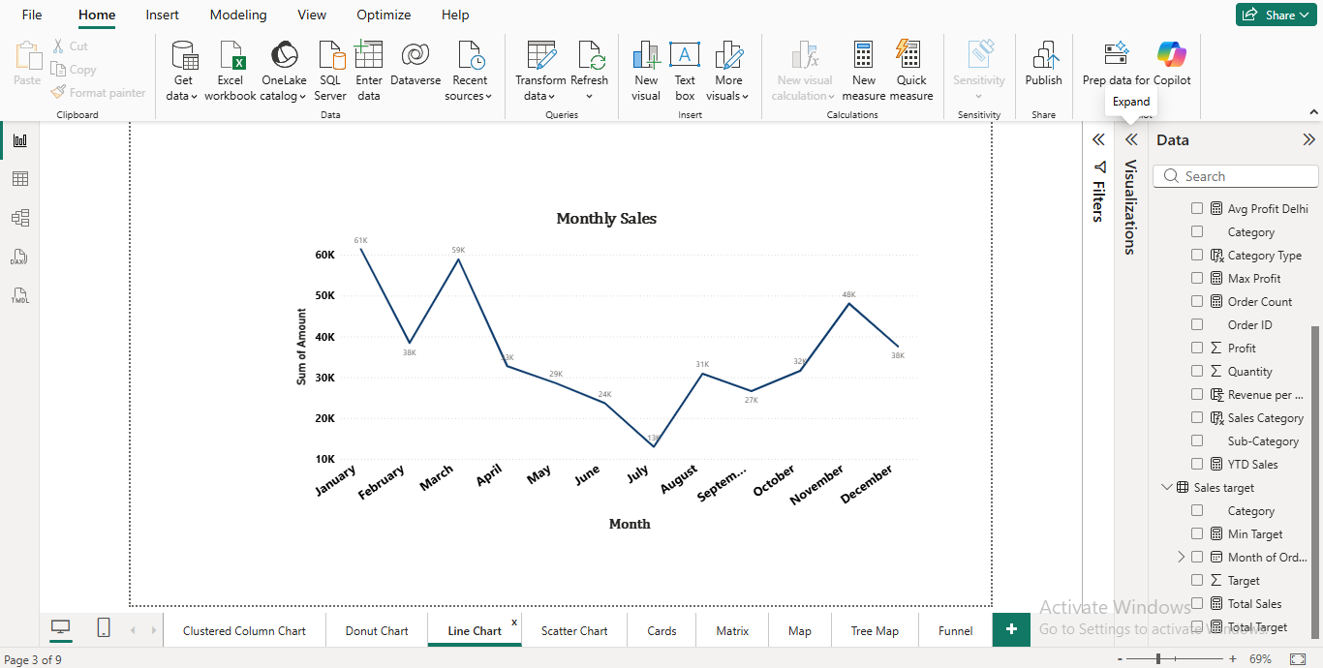
Scatter chart:
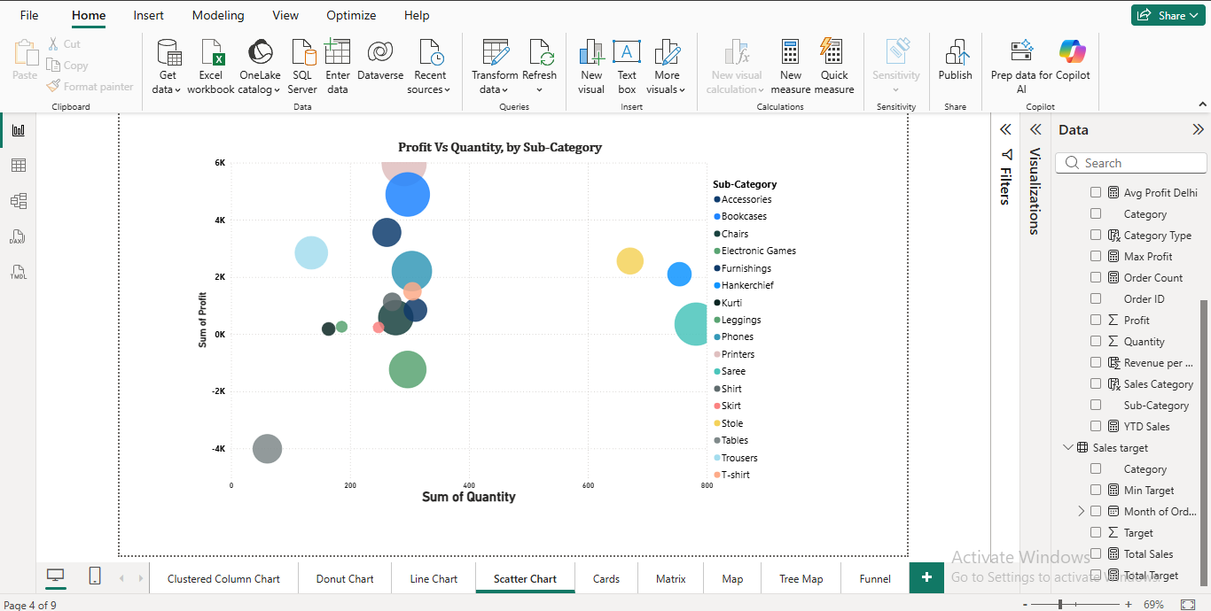
Total Sales Amount and Target:

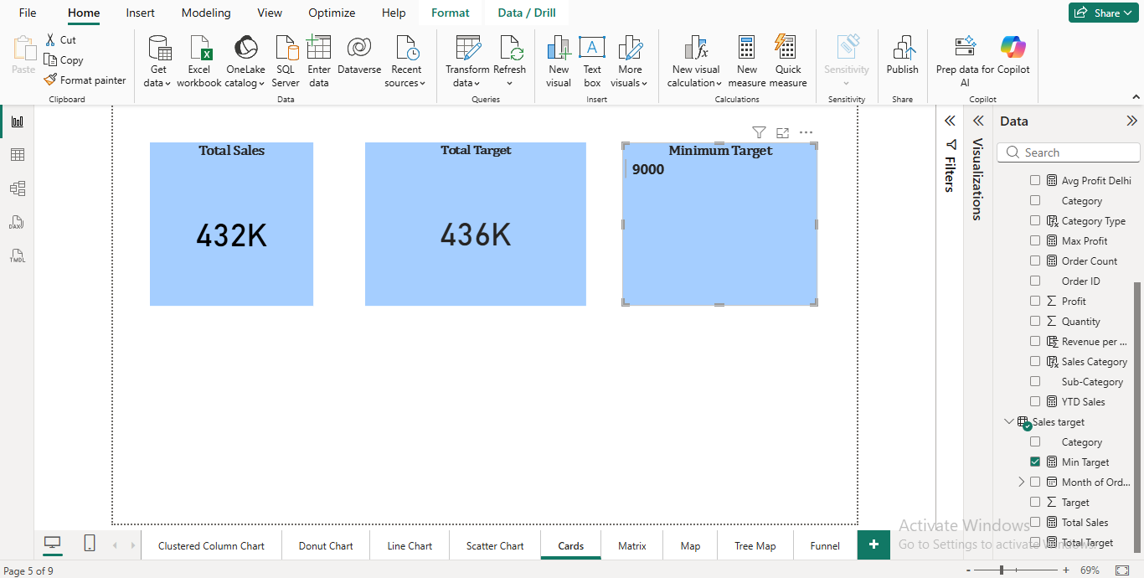
Sales Performance Matrix:
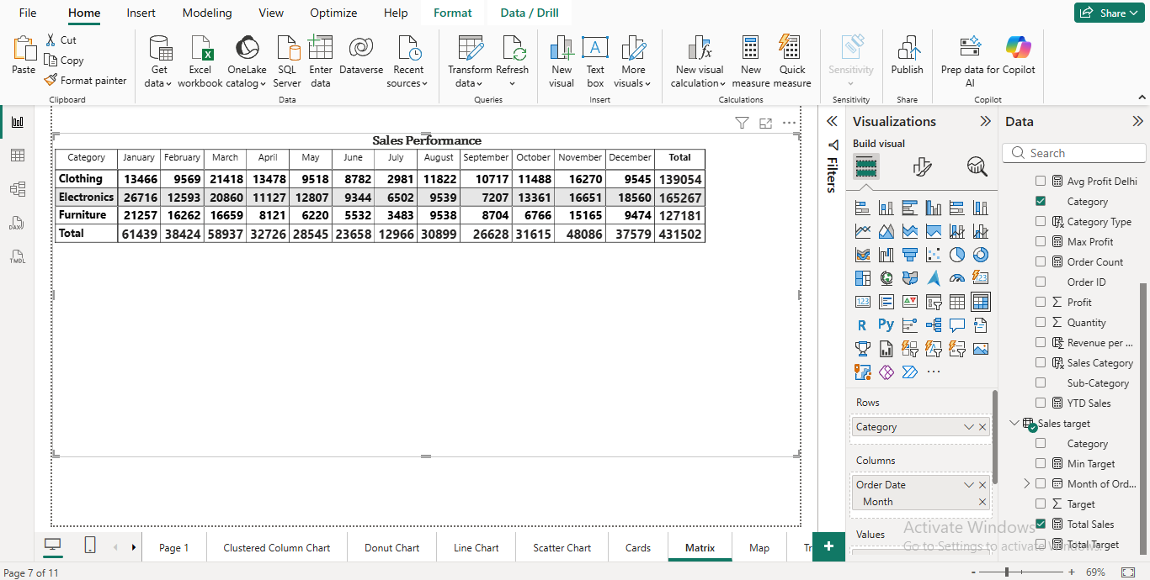
Geographic Sales Analysis:

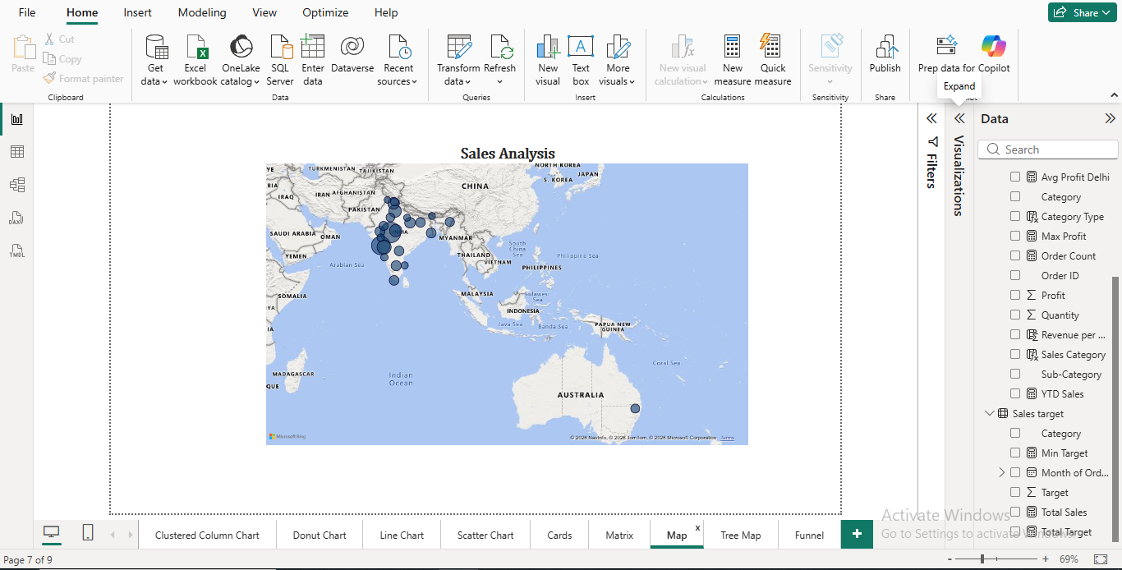
Sales Distribution by Sub-Category:
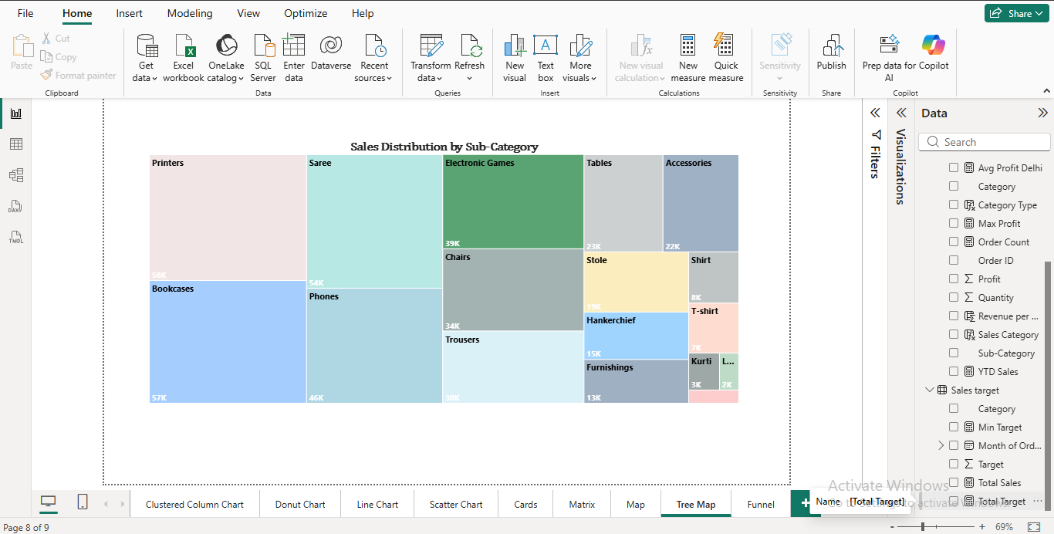

Order Count Analysis by State:
